Metal Wallet
# Source: AI Source: Provided by: [Data Path: Persons Table -> ID Column: 1, Name_En Column: Motasem Essam] -> From: [ChatGPT] on [1/21/2026]
A Metal Wallet is not a standalone wallet like others, but rather a durable backup method for storing your seed phrase or private key used in cold wallets. It is designed to physically preserve recovery data in a fireproof, waterproof, and tamper-resistant metal format, ensuring that your wallet’s backup survives disasters.

🪙 Key Characteristics of Metal Wallets:
# Source: AI Source: Provided by: [Data Path: Persons Table -> ID Column: 1, Name_En Column: Motasem Essam] -> From: [ChatGPT] on [1/21/2026]
- Physical Backup Tool
  - Stores a 12, 18, or 24-word seed phrase in engraved or punched form.
  - Complements hardware, paper, air-gapped, or software wallets.
- Disaster-Resistant
  - Made of steel, titanium, or aluminum.
  - Resistant to fire (over 1000°C), water, corrosion, and physical damage.
- No Electronic Components
  - Completely offline and passive — no risk of remote compromise.
- Supports BIP39 Standards
  - Compatible with most wallets using BIP39 mnemonic phrases (e.g., Ledger, Trezor, MetaMask, Electrum, etc.).

🛠️ How It Works:
# Source: AI Source: Provided by: [Data Path: Persons Table -> ID Column: 1, Name_En Column: Motasem Essam] -> From: [ChatGPT] on [1/21/2026]
- During wallet setup (e.g., hardware or software), a seed phrase is generated.
- Instead of writing it on paper, the user engraves, stamps, or slides letters into a metal plate.
- The metal wallet is stored in a safe, vault, or hidden location.
- If the original wallet is lost or destroyed, the metal wallet can be used to recover funds on any compatible wallet app.

🔧 Popular Metal Wallet Products:
# Source: AI Source: Provided by: [Data Path: Persons Table -> ID Column: 1, Name_En Column: Motasem Essam] -> From: [ChatGPT] on [1/21/2026]
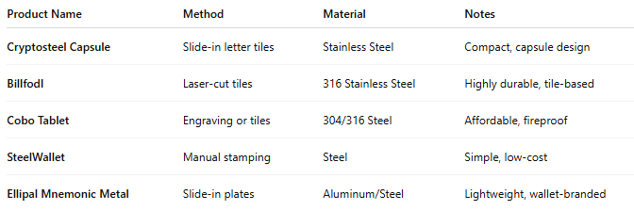

Product Name | Method | Material | Notes
Cryptosteel Capsule | Slide-in letter tiles | Stainless Steel | Compact, capsule design
Billfodl | Laser-cut tiles | 316 Stainless Steel | Highly durable, tile-based
Cobo Tablet | Engraving or tiles | 304/316 Steel | Affordable, fireproof
SteelWallet | Manual stamping | Steel | Simple, low-cost
Ellipal Mnemonic Metal | Slide-in plates | Aluminum/Steel | Lightweight, wallet-branded

✅ Advantages:
# Source: AI Source: Provided by: [Data Path: Persons Table -> ID Column: 1, Name_En Column: Motasem Essam] -> From: [ChatGPT] on [1/21/2026]
- Disaster-proof backup of seed phrase
- Far more secure and durable than paper wallets
- No risk of online compromise
- Works with any wallet using mnemonic recovery

⚠️ Disadvantages:
# Source: AI Source: Provided by: [Data Path: Persons Table -> ID Column: 1, Name_En Column: Motasem Essam] -> From: [ChatGPT] on [1/21/2026]
- Can be costly compared to paper ($30–$100+)
- If lost or stolen, the seed phrase is fully exposed to the finder
- Manual engraving/stamping requires precision and privacy

🧠 Best Use Cases:
# Source: AI Source: Provided by: [Data Path: Persons Table -> ID Column: 1, Name_En Column: Motasem Essam] -> From: [ChatGPT] on [1/21/2026]
- Backing up hardware or paper wallets
- Long-term HODLers storing seed phrases securely
- Crypto users seeking disaster-resistant recovery options
- Institutional or multi-sig key management setups

🆚 Compared with Other Storage Options:
# Source: AI Source: Provided by: [Data Path: Persons Table -> ID Column: 1, Name_En Column: Motasem Essam] -> From: [ChatGPT] on [1/21/2026]
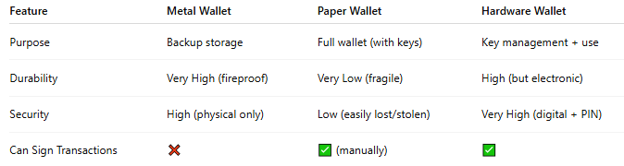

Feature | Metal Wallet | Paper Wallet | Hardware Wallet
Purpose | Backup storage | Full wallet (with keys) | Key management + use
Durability | Very High (fireproof) | Very Low (fragile) | High (but electronic)
Security | High (physical only) | Low (easily lost/stolen) | Very High (digital + PIN)
Can Sign Transactions | ❌ | ✅ (manually) | ✅

🔐 Security Tips for Metal Wallets:
# Source: AI Source: Provided by: [Data Path: Persons Table -> ID Column: 1, Name_En Column: Motasem Essam] -> From: [ChatGPT] on [1/21/2026]
- Don’t label the metal plate (avoid associating it with crypto or your name).
- Store in a hidden or locked location (safe, bank vault, etc.).
- Consider using a passphrase with your seed for added protection.
- Do not photograph or digitize the metal wallet.

